A COMPREHENSIVE ANALYSIS OF FINANCIAL PERFORMANCE OF

FROM A LEADING BANKS: INSIGHTS FROM A LEADING BANKS

# PROJECT REPORT

**1.INTRODUCTIONS**

* 1. **Overview**

The banking industry world-wide is being transformed. The global forces for change include technological innovation; the deregulation of financial services at the national level and opening-up to international competition; and-equally important – changes in corporate behaviour, such as growing disintermediation and increased emphasis on shareholder value. In addition, recent banking crises in Asia and Latin America have accentuated these pressures. In this project we are trying to analysis the bank related data and able to extract some insights from the data using business intelligence tools.

* 1. **Purpose**

The purpose of financial analysis is aims to analyse whether an entity is stable, liquid, solvent, or profitable It is used to evaluate economic trends, set financial policies, build long-term plans for business activity, and identify projects or companies for investment. To assess financial statements which contain information on past performance and interpret it as a basis for forecasting future rates of return and for assessing risk. For determining the credit risk, deciding the terms and conditions of a loan if sanctioned, interest rate, and maturity data.

**2. PROBLEM DEFINITION AND DESIGN THINKING**

**2.1 Empathy Map**

**2.2 BRAINSTORMING MAP AND IDEATION**

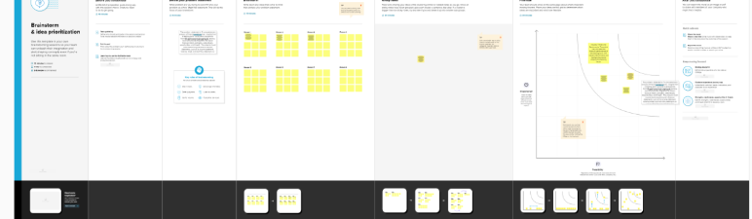

**3.RESULTS**

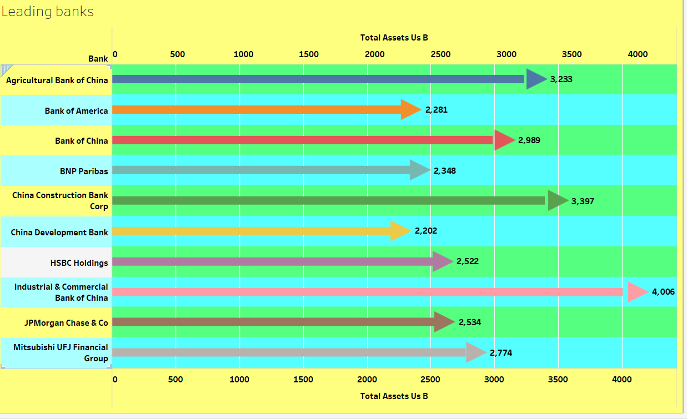

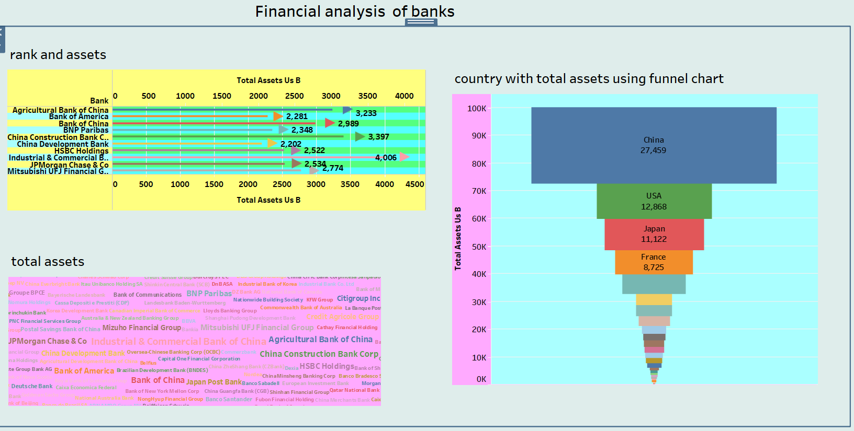

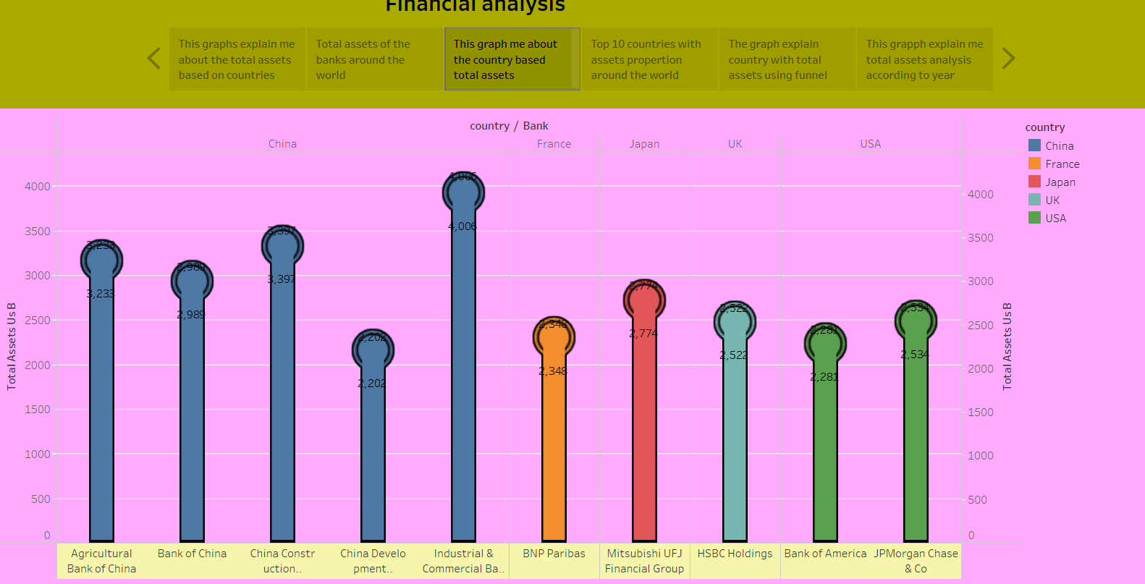



**4 1. ADVANTAGES**

* It provides on overview of how well the company manages its assets and liabilities. Analysis can find information about long – term vs. short – term debt on the balance sheet.

*They can also find information about what kind of assets the company owns and what percentage of assets are financed with liabilities vs.

*It provides financial information such as the company assets structure, asset ability, source of funds, debt level, and liability structure. Thus according to financial tools to analyse to each part of financial statement is useful for avoiding financial risk

.

**2.DISADVANTAGES**

*Based on markets patterns: One disadvantage of using financial statements for decision making is that the data and figures are based on the market at that given time. It may sell much less if a competitor releases a similar product.

*Limitations: Financial statements does not contain some intangible assets. Only cover a specific period of time it may not be comparable. It could be wrong due to fraud.

*At one time analysis: Financial statements limitations comprise concerns relates to fraudulent practice while recording information, dependency on historical costs, lack of comparability and non- adjustability to inflation that the analysis cannot overlook.

**5.APPLICATION**

*Interest margin: One of the most important KPIs for banks net interest margin reveals a banks net profit on interest earing assets, such as loans or investments securities. Since the interest earned on these assets as a primary source of revenue for a bank, this metric can indicate a banks overall profitability.

**\***Balance sheet: A statement that lists a business revenues, expenses, and profits over a period. It is a list of assets, liabilities, and owner equity at a point.

*Cash flow statement: A statement that captures how cash flow is affected by activities from the balance sheet and income statement, categorized into operating, investing, and financing activities.

*Annual report: A document that describes the company operation and financial conditions, and typically includes the documents listed above in addition to other insights and narrative from key figure within the company.

**6.CONCLUSION**

**\***A company is solvent when it is able to honour all its commitments by liquidating all of its assets, i.e., if it ceases its operation and puts all its assets ups for sale. Solvency depends on the break- up value of a company assets, and the size of the debts. Net assets, i.e., the difference between assets and total liabilities are the traditional measure of a company solvency.

*A company creates value if the return on capital employed that it generates exceeds that served to finance capital employed.

*Lastly , we recommend the readers that who need to carry out a rapid assessment of an ailing company where the accounts are not yet available build a cash flow statement in reverse. This reverse approach starts with reduction in net debt and works back towards net income, the gauging the scale of losses that put the company solvency and very survival in jeopardy.

**7.FUTURE SCOPE**

*Evaluating company financial performance requires you to: analyse financial ratios to assess profitability, solvency, working capital management, liquidity, and operating effectiveness. Compare current performance with historical conditions using trend analysis. The banking sector mainly recruits for three posts- clerical cadre, management and trainee and probationary officer. Other opportunities in this career path are financial service representatives, bank tellers, bill and account collectors, loan officer, financial managers, bookkeeping, and audit clerks. The objective of financial statement is to provide information about the financial positions, performance and changes in financial position of an enterprise that is useful to a wide range of users in making economic decisions.

**8.APPENDIX**

**SOURCE CODE**

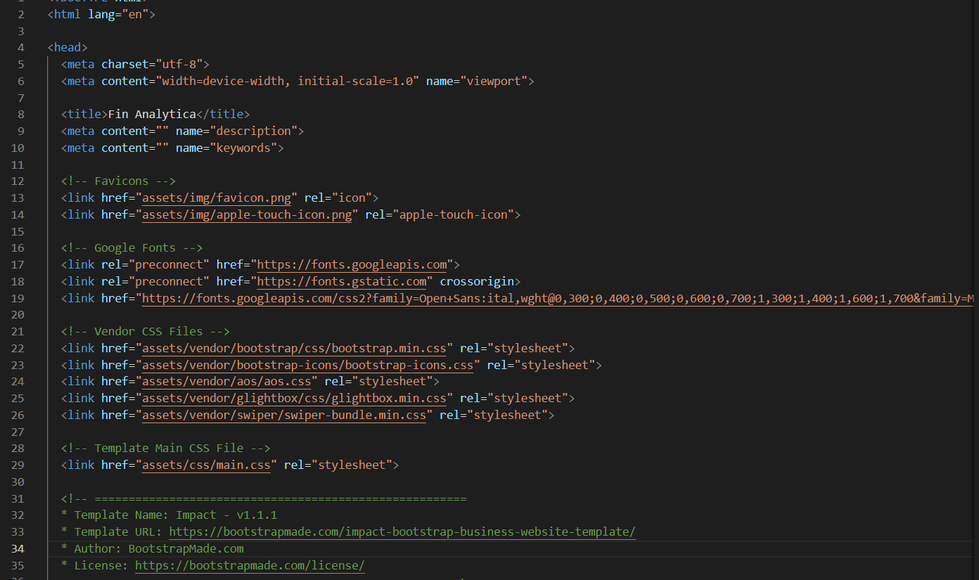

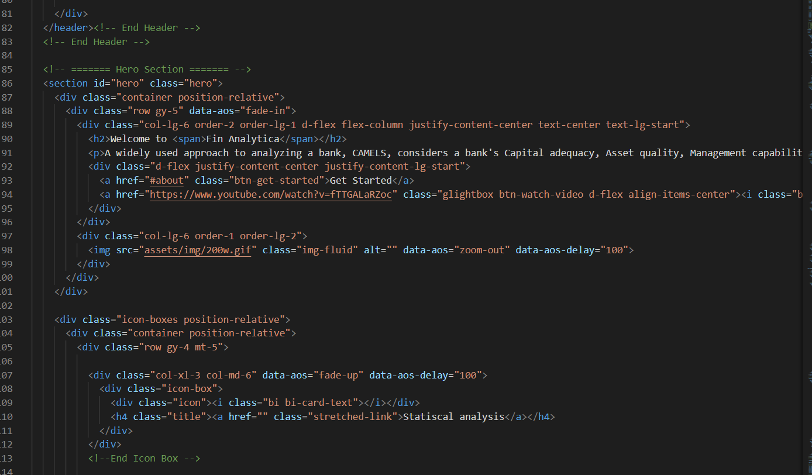

**SOURCE FOLDER LINK :**

[**https://drive.google.com/file/d/11C-9EiK9AB5MwjLNhQYmuPByc67Yn8ef/view?usp=share_link**](https://drive.google.com/file/d/11C-9EiK9AB5MwjLNhQYmuPByc67Yn8ef/view?usp=share_link)

**SOURCE CODE LINK :**

[**https://drive.google.com/file/d/1SRA3ZmvxodiJSLgAFZaOIDdXSHxxyId4/view**](https://drive.google.com/file/d/1SRA3ZmvxodiJSLgAFZaOIDdXSHxxyId4/view)

**VIDEO LINK:**

[**https://drive.google.com/file/d/1oJWiA_RqGfZEy5Idu0_31kxitDjtynvk/view?usp=share_link**](https://drive.google.com/file/d/1oJWiA_RqGfZEy5Idu0_31kxitDjtynvk/view?usp=share_link)

**TABLEAU PUBLIC:**

**STORY:**

[**https://public.tableau.com/app/profile/pushpa.gayathri.b/viz/story_financialanalysis/Story1**](https://public.tableau.com/app/profile/pushpa.gayathri.b/viz/story_financialanalysis/Story1)

**DASHBOARD:**

[**https://public.tableau.com/app/profile/pushpa.gayathri.b/viz/Dashboard_Financialanaysisofbanks/Dashboard1**](https://public.tableau.com/app/profile/pushpa.gayathri.b/viz/Dashboard_Financialanaysisofbanks/Dashboard1)